Fondo: #302837



Textos/Items: #F9CEC2

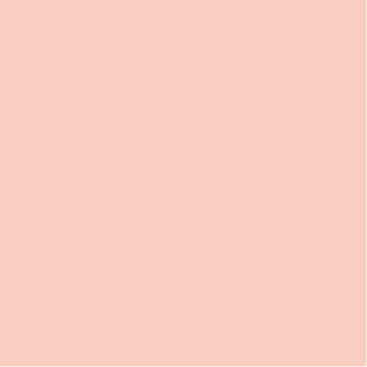

Fondo verde: #006552



Paredes verde: #025241

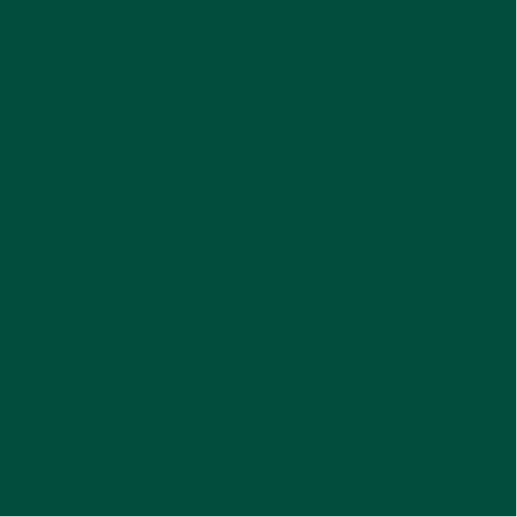

Agua: #77c8d4

Lava: #a14e4a

Version azul:

Piso: #025860

Pared: #02464d

Version violeta:

Piso: #4c2e4f

Pared: #402742